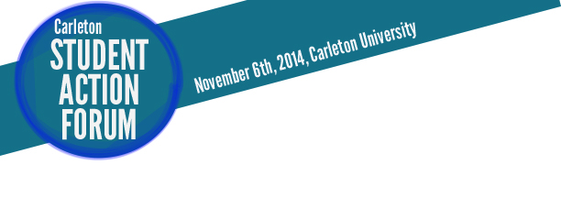
Registration form

The Student Action Forum is a full day of free workshops and events, bringing together Carleton students from across the campus to build skills and share knowledge around community building and social justice. We will explore such topics as campaigns organizing, media training, meeting facilitation, and building inclusive movements. We’ll look at the pertinent issues facing our campuses today, from rising tuition fees to racism and colonization, and we‘ll discuss what meaningful student action can look like.

GENERAL INFORMATION (Please print)

Name:

Email:

Phone Number:

Program:

Year of study:

DIETARY RESTRICTIONS:

Registration forms can be brought to the GSA reception, 6th floor UC, or emailed to mc@gsacarleton.ca.

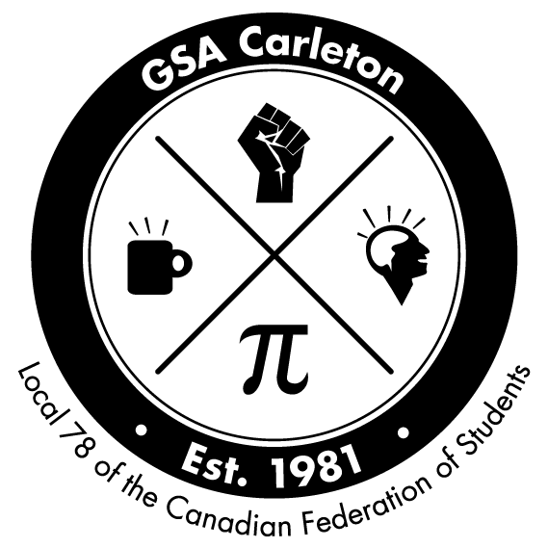
Organized by the Carleton Graduate Students’ Association
and the Canadian Federation of Students - Ontario

