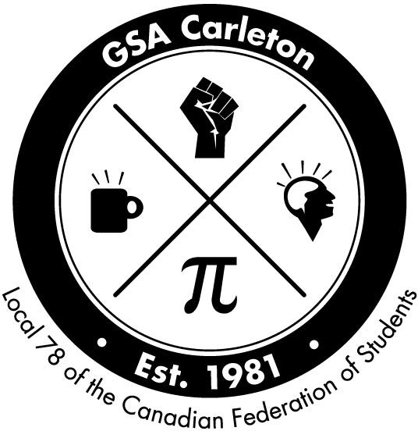
GSA Indigenous Student Award Application Form, 2020/21
The GSA Indigenous Student Award was created to help alleviate the financial burdens Indigenous students incur while obtaining university degrees. Applicants must be members of the GSA. . Three $750 awards are given out each term in the year. The deadline for application is last day of first month of each term, at 4pm. Please submit your application to the GSA offices at 600 UC, phone (613)520-6616, email gsa@gsacarleton.ca.

Eligibility
- Applicants must be a member of the GSA.
- Applicants must demonstrate financial need.
- Applicants must not have any other source of funding like TA, RA.
- Applicants must be in good academic standing, as defined by Carleton’s graduate calendar.
- Applicants must have completed at least one term of graduate study at Carleton.

Procedure
Applicants must submit the following:

Submitted Notes

- A completed and signed application form
- A cover letter (1-2 pages), outlining reasons for eligibility, and
emphasizing academic excellence and financial need
- Current Carleton transcript (a photocopy is acceptable)

Personal Information
Last Name Local Address
Local Phone Number

First Name(s)

Email Address

Student #

Department/School/Institute
Level of Study (circle)
MA PhD

Declaration:
I hereby declare that all information given in this application is true and complete to the best of my knowledge. I understand that I may be required to repay all or part of this scholarship if the informa- tion provided is found to be inaccurate.

Signature
Date
Rec’d by

