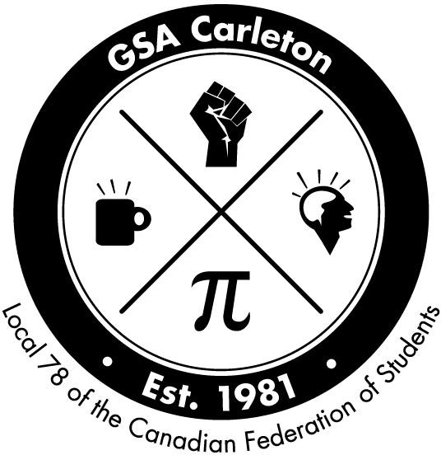
GSA Domestic Student Award Application Form, 2021/22
The GSA Domestic Student Award was created to help alleviate the financial burdens domestic students incur while obtaining university degrees. The GSA recognizes that recent changes to the OSAP funding of domestic students has decreased and that a major part of OSAP grants is converted to OSAP loans, as well as the grace period of six months for OSAP loan after graduation is reduced. Applicants must be members of the GSA. Three $750 awards are given out each Fall and Winter term in the year. The deadline for application is last day of first month of each term, at 4pm. Please submit your application to the GSA offices by email at gsa@gsacarleton.ca.

Eligibility
- Applicants must be a member of the GSA.
- Applicants must not have any other source of funding, external or internal, including TA or RA.
- Applicants must have completed at least two terms of graduate study at Carleton.
- Applicants must be in good academic standing, as defined by Carleton’s graduate calendar.
- Applicants must be a permanent resident or citizen of Canada.

Procedure
Applicants must submit the following:

Submitted Notes

- A completed and signed application form
- One reference from professors or graduate administrators, confirming that the student does not have any external or internal funding.
- Applicants must be able to show proof of OSAP loan for the term.
- An academic transcript from Carleton University (photocopies are accepted too).

Personal Information
Last Name Local Address
Local Phone Number

First Name(s)

Email Address

Student #

Department/School/Institute
Level of Study (circle)
MA PhD

Declaration:
I hereby declare that all information given in this application is true and complete to the best of my knowledge. I understand that I may be required to repay all or part of this scholarship if the information provided is found to be inaccurate.

Signature
Date
Rec’d by

