**LIQUOR/WINE MOCKTAILS**

**_______________________________________ _______________________________________**

**LIQUOR: 1 OZ POUR $5.29 CORONA SUNBREW 0% $4.49**

**1 OZ POUR WITH MIXER $6.29**  **BECK’S, HEINEKIN 0%,**  **$4.49**

**HOUSE CHARDONNAY OR CABERNET MERLOT GUINESS “0” $5.99**

**5 OZ - $7.99 8 OZ - $10.99**

**BOTTLES/CANS MIKE’S FAVOURITES**

**________________________________________ _____________________________________________ SELECT: $6.89 CHEESESTICKS $6.99 **

BELGIAN WHITE, COORS LIGHT, CANADIAN,  **VEGETABLE SAMOSA** **$4.49 **

KEITH’S, RICHARDS RED  **VEGETABLE SPRINGROLLS** **$4.99 **

**PREMIUM: $7.99 POPCORN SHRIMP**  **$6.99**

CORONA, HEINEKEN, STELLA, NO BOATS CIDER  **BAGEL BITES (CHEESE OR PEPPERONI)** **$4.99**

GLUTENBERG, GUINESS, BEAU’S, TOWN AND COUNTRY  **PRETZEL** **$5.99 **

**SPECIALTY: $7.49 FRENCH FRY $4.49 **

SMIRNOFF ICE, TWISTED TEA, **NACHO CHIPS/SALSA $4.29  #**

MIKE’S HARD LEMONADE  **MIKE’S CHICKEN TENDERS WITH DIP $6.49**

**SPACE INVADERS 568ML $8.49 RANCH, HONEY MUSTARD, PLUM, BUFFALO**

**SUNSPLIT IPA 473 ML $8.49**

**BEVERAGES/SNACKS**

****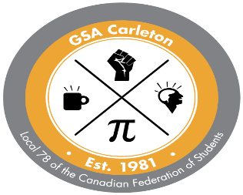______________________________**

**TEA/COFFEE $1.49/$1.99**

**HOT CHOCOLATE $1.99**

**CANNED POP $1.59 MONSTER $3.49**

**WATER: PERRIER $3.59 DASANI $2.29**

**CHIPS $1.89/2.29 CHOCOLATE BAR $1.99**

**PEANUTS $1.69 GUM $1.79 MINTS $1.69**

**COOKIES $1.19 OR 2 FOR $2, POPCORN $2.99 VEGETARIAN HALAL # GLUTEN FREE **CONTAINS NUTS**